# Detailed Case Study

# Development of online data-driven monitoring methodologies and piloting analytical and monitoring tools by the State Audit Service of Ukraine –

# Development and implementation of front-end analytical tool

## Big data and data analytics-based online monitoring of public procurement

### Data-driven and risk-based front-end tool for monitoring digital procurement transactions using the Open Contracting Data Standard – Transformation and Analytics

|  |  |  |  |
| --- | --- | --- | --- |
|  | **Lead Organisation**:  State Audit Service of Ukraine (SASU);  Ministry for Development of Economy, Trade and Agriculture (MDETA);  European Bank for Reconstruction and Development (EBRD). |  | **Location:** Ukraine |
|  | **Problem Statement:** At any one time, the national e-procurement system of Ukraine (Prozorro) contains up to **18,000 active procedures** at various stages, 9% of which are marked as risky, and the State Audit Service of Ukraine (SASU) has limited auditors’ resources engaged in carrying out monitoring. Auditors are expected to manage their workflow in a way that they are able to select for monitoring first the procedures where the **risk of violation is the most likely** and/or the **amount of possible loss is the biggest** so that the monitoring process is most effective and efficient by focusing on those procurement procedures that could potentially cause the most significant losses of public funds. Notwithstanding this, the proof of the concept assignment **demonstrated** **the feasibility of the data-driven risk-based approach** of digital procurements monitoring by developing practical methodologies and supporting tools to capture risks described in these methodologies. **It didn’t account for auditors’ user experience** and the generated risk data remained hard to navigate and treat without the appropriate visual interface, which could support auditors decision making process of procedures selection into monitoring. | | |
|  | **Description:** The project aimed at supporting the SASU auditors in piloting the developed conceptual design of the data-driven and risk-based digital procurements monitoring approach. To support the pilot and the change program, a **tool that could automatically consolidate the procurement procedures risk data** **accumulated in real-time** to enable auditors effectively and quickly select procedures for monitoring was developed. Also, the SASU needed analytical infrastructure and additional technical capacity **to analyse sets of procurement procedures in various dimensions** as the Auditor’s electronic Cabinet offers no filters, search engine or other useful functionality for querying procedures and processing the monitoring. | | |
|  | **Lessons learnt:**  1. The assignment piloted the online monitoring methodologies and OCDS based analytical infrastructure and **proved that the online monitoring concept is viable for the Ukrainian public procurement environment**.  2. Organising a **discussion among experts** in the field aiming at the **investigation of public procurement risks and their minimisation** through the online monitoring and other means of controls is recommended.  3. There is a need for dedicated **guidance for efficient and effective monitoring** of public procurement procedures.  4. **The developed IT infrastructure** for the public procurement monitoring needs to be **revised and updated** to reflect the necessary amendments to the online data-driven monitoring methodology, monitoring process performance assessment, and incorporating automatic reports on the progress of online monitoring effectiveness. | | |
|  | **Cost:** ≈**€70 000** (the main factor impacting the cost of equivalent projects is the quality of the underlying data) |  | **Impact**: Auditors can conduct a **real-time and in-depth analysis** of eProcurement transactions, and **effectively select for monitoring** by applying available analytical functionalities and calculated risk indicators results, displayed live in the user-friendly web-based application. |
|  | **Human resources:** Project implemented by **EBRD and one consulting contractor**, providing expertise in risk management, business intelligence software, OCDS, web applications, data analysis and capacity-building. |  | **Risks:** Gaining **auditors support** in the design and testing process is required for the development of the analytical tool that will meet end-users’ expectations in full. |
|  | **Project timeline**: Aug 2019 – Jan 2020 |  | **Project status:** In use by the SASU since January 2020 |
|  | **Email:** NiewiadE@ebrd.com |  | **Website:** No public access. The tool is restricted for the SASU users only |

#### Context and problem statement

In April 2016, the [Public Procurement Law](https://zakon.rada.gov.ua/laws/show/922-19) (Law) came into force in Ukraine. Together with the new Law, the **public procurement monitoring** procedure was introduced. The Law defined the procurement monitoring procedure as the **analysis of contracting authority** **procurement practices** at all stages of procurement procedure for compliance with the Law in order **to** **prevent a breach of legislation**. The [State Audit Service of Ukraine](http://www.dkrs.gov.ua/kru/en/) (SASU) was assigned as the governmental authority responsible for performing public procurement monitoring.

To analyse information signalling the presence of signs of violation in the field of public procurement, the SASU needs to **process a huge amount of data from various sources**. In 2019, with the cooperation between the Government of Ukraine, [Transparency International Ukraine](https://ti-ukraine.org/en/) and the EBRD, a set of **automatic risk indicators** was developed that indicate the likelihood of the existence of offences in procurement procedures.

Under the TC project, the software, including **35 automated risk indicators**, was successfully implemented and put into operation. This software **automatically checks** procurement procedures against developed risk indicators and forms an **ordered list** **of procedures** that have been recognised as risky. The ordered list of selected risky procedures then is shown in the **electronic Auditor’s Cabinet**, developed by SE “Prozorro” as an auditor’s dedicated tool for **initiation** and **conducting** monitoring process as well as official **communication** with the contracting entities within the monitoring procedure and publication of the monitoring **conclusion**.

However, the state auditors expressed interest in the **functionality that was not covered by the developed solution**. What they had in the Auditor’s Cabinet was that for all risky procedures in a queue marked as a priority, the system generated drafts for future monitoring automatically. To be able to understand for which procedure the draft was created and what indicators showed the positive calculation results for this procedure, the auditor had to go inside the draft. As a result, the auditor was forced to go **manually throughout all drafts** **to select the required data, and this procedure could take a lot of time**.

In addition, the Auditor’s Cabinet offered **no filters, search engine or other useful functionality** **for querying** as well as **processing** monitoring drafts. SASU had need of analytical infrastructure and additional technical capacity **to analyse procurement procedures more efficiently** and focus on those procurement procedures where the risk of violation is the **most likely** and/or that could potentially cause **significant losses** of public funds.

#### Objectives and vision

Working with the EBRD GPA Technical Cooperation Facility, the SASU and MDETA aimed to **modernise existing public procurement monitoring infrastructure** by introducing a modern user-friendly electronic analytical tool that could support auditors by automatically consolidating transactions data accumulated in real-time from various Open Data sources to enable them to:

* analyse sets of procurement procedures in various dimensions, and
* effectively and quickly select procedures for monitoring.

The EBRD-developed vision to achieve these objectives contained two primary workstreams:

* **Development and implementation of the front-end analytical tool** for exploring and queuing ‘red-flags’ based transactional risk indicators with the methodology for procedures queue forming, KPI calculation and their visual interpretation;
* **Conducting an online training session for end-users** – members of the SASU staff responsible for monitoring public procurement to enable them to implement eProcurement audit activities.

#### Technological solution and implementation

The development of the front-end analytical tool began by discussing and agreeing on the **functional and non-functional requirements**. The project team defined the basic modules of the analytical tool and prepared the necessary technical documentation. Then, the required **mock-ups** of the future tool’s interface were designed and approved, including elements of control, forms for displaying the calculation results, sets of analytical dashboards and their location.

The next step was the development of the **module for** **selecting and consolidating the data** from identified sources of information. The output of this phase was a structured central database of the analytical tool, which enabled the consolidation of all the data needed to perform further analysis of procurement transactions.

Once the analytical tool interface was displaying an array of procedures in a table format, **the table metrics ware introduced**, for instance, the number of transactions in the table, the number of transactions, etc., to summarise the amount of data that the end-user is currently working with. The result of this phase was the completed functionality for the visualisation of the transactions array.

Next, the **functionality of filters** for a general and selected array of procurement procedures was developed and tested. Filters enable auditors to consider the array of public procurement transactions in different dimensions. The analytical information presented graphically helps auditors to localise risks in the public procurement system under different dimensions and more efficiently select transactions for monitoring and the **functionality of the basket** provides auditors with the capability to store selected procurement transactions up to the official initiation of monitoring.

The last functionality implemented was **transaction marking**, which serves to visually mark such procurement procedures, in the framework of which the special events occurred, which should be reported to the auditor. Following the development of the analytical tool, the auditors tested it and, based on the results of the tests, final amendments were made, and all identified bugs were eliminated. At the end of this phase, the front-endanalytical tool was ready for deploymentinto a production environment of the Beneficiary.

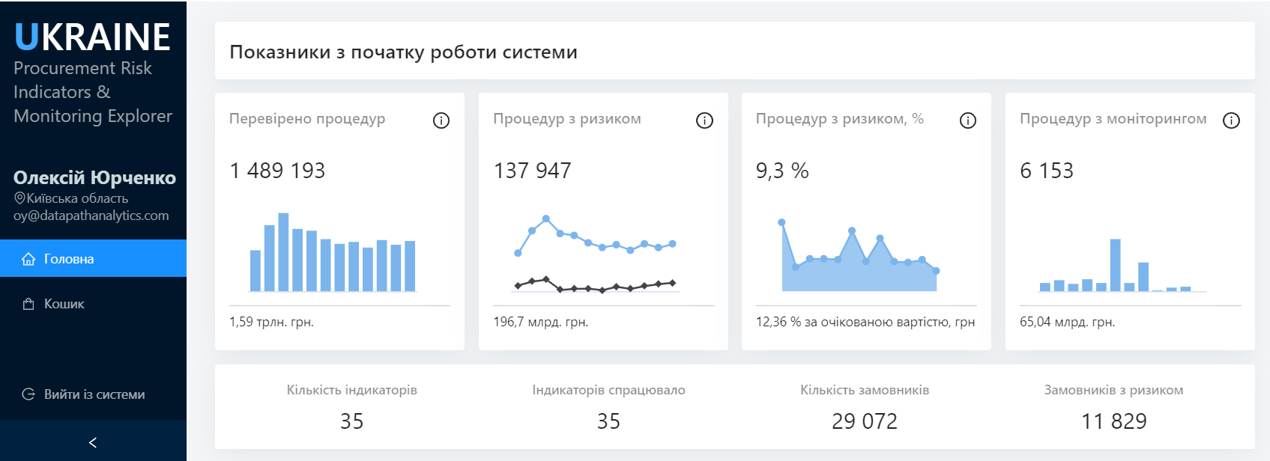***Figure 1 Interface of the application working area***

***Figure 2 View of the section “Selection of procedures with risk indicators triggered”***

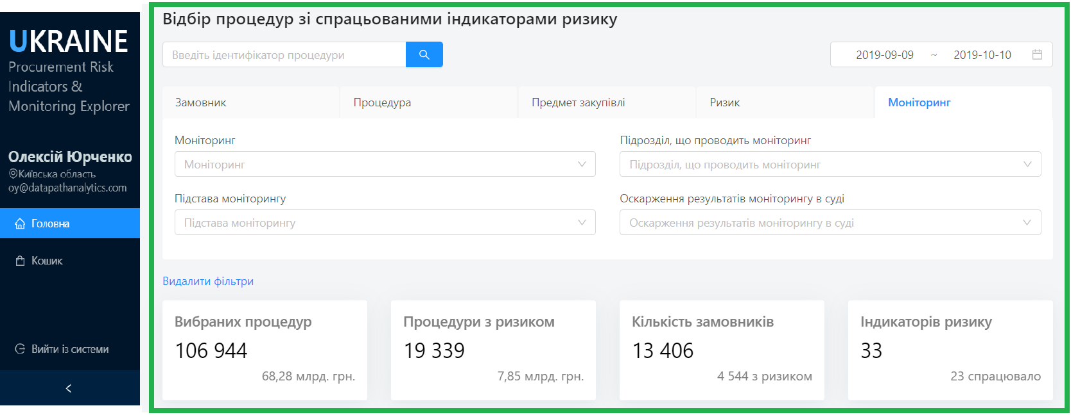

***Figure 3 Examples of analytics view***

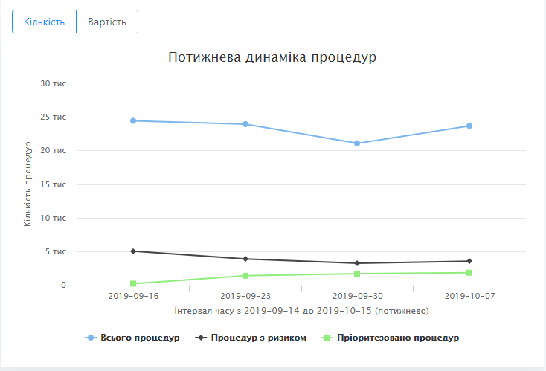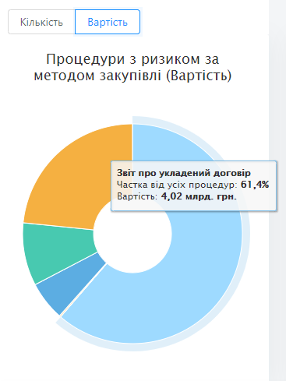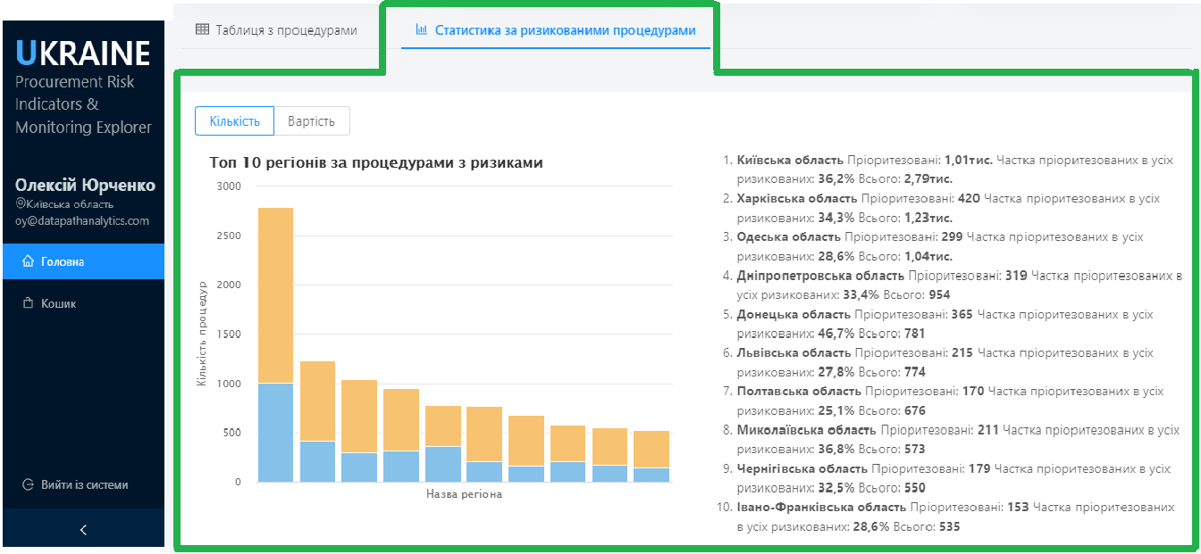

#### Results and future expectations

The implemented project proved that the online risk-based data-driven monitoring concept is viable for Ukrainian public procurement environment. The user-friendly tool automatically consolidates and visualises data from the Prozorro, the automatic risk indicators calculation engine and the Prozorro API for monitoring and allows auditors to quickly analyse transactions’ open data by applying multidimensional filtering functionality. Also, a dedicated basket functionality was implemented to keep the procedures and track them by auditors until the official start of monitoring.

Following the completion of the capacity-building training sessions, the staff of the SASU responsible for monitoring public procurement in Ukraine, have significantly increased their capabilities in conducting eProcurement audit activities using a new monitoring methodology and analytical tools.

The project deliverables contribute to improving the CAs procurement practice compliance with regulations, as well as a higher level of the corruption or collusion cases detection by the state controlling authorities, and to reduce the loss of public funds.

#### Costs and requirements

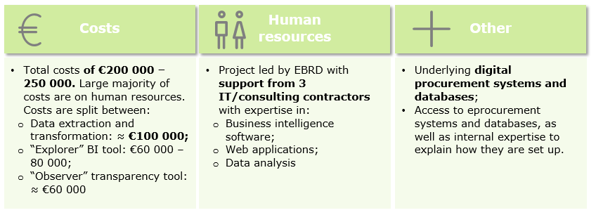

|  |  |  |
| --- | --- | --- |
| * + Total costs **of** ≈**€70,000** | * Project led by the EBRD with **support from one IT/consulting contractor** with expertise in:   + Risk management;   + Business intelligence software;   + OCDS implementation;   + Web applications;   + Data analysis;   + Capacity-building. | Available data via OCDS APIs |

The OCDS-based front-end analytical tool was developed for a total cost of about **€70 000**. The large majority of these costs are focussed on the human resources required to first analyse the existing processes and systems, and then develop the tailored data extraction, transformation, and analytical tools needed. The **breakdown of costs** is roughly as follows:

* Conducting desk-based research and business analysis, interviewing stakeholders and preparation of an **Inception report and work plan** – roughly €20 000.
* Preparation of required **data infrastructure**, **development and implementation of front-end analytical tool** for exploring and queuing ‘red-flags’ based transactional risk indicators with the methodology for procedures queue forming, KPI calculation and their visual interpretation – €40 000. The main variable affecting the cost of this development is the data quality and supporting of the local stakeholders.
* Preparation of materials and conducting the **capacity-building** online **training sessions** for end-users – roughly €10 000.

In terms of the **human resources required for the project**, the EBRD worked with one consulting company in order to develop the system and conduct a training session. The company possessed all needed skills in risk management, OCDS data analysis, BI tools development and capacity-building.

#### Risk and mitigation

**Risks related to political processes in the country – change of the Government team:** after the presidential and parliamentary elections, the risk that a new team from the government side would affect the project execution increased. The possible impact of the project slowing down or even cancellation was considered. The project team confirmed with stakeholders that the project objectives remain relevant. There were no significant staff changes within the stakeholders’ team during the project implementation period, which allowed to achieve project objectives within the planned scope and schedule.

**Risk of exceeding development time** – **the development process has a risk of exceeding the deadlines for scheduled software releases**. To reduce this risk in the development process, we used the Scrum approach – the Agile process framework for managing complex software development. It allowed us to meet the scheduled time and scope without any delays.

Another detected issue was the **risk of exceeding the agreed time for conducting training sessions due to unavailability of the end-users** from the Regional Offices of the SASU. To reduce the probability of this risk, the project team was constantly in contact with the senior management of the SASU, and also developed and agreed on compromise option for conducting a capacity-building training - to perform an online training session for all available end-users from the Regional Offices of the SASU, and then share the training video with all end-users who were unable to participate.

#### Challenges and lessons learnt

Gaining **auditors support** in the design and testing process is critical for the development of the analytical tool that will meet end-users’ expectations in full.

Lessons that can be taken from the project:

* Analysing the changes in the public procurement control environment, as well as upcoming amendments to the related legislation, we suggest **organising a discussion among experts** in the field aiming at the **investigation of public procurement risks and their minimisation** **through the online monitoring** and other means of controls.
* Based on interviews with stakeholders, we noted the need for **dedicated guidance for efficient and effective monitoring** of public procurement procedures. The guidance should include an assessment of the monitoring process effectiveness, including (1) a step by step description of the monitoring process and how to use the developed technology infrastructure, and (2) monitoring process KPIs to measure the effectiveness of the auditors, risky procedures queueing and prioritisation, queue processing, as well as an explanation on how to effectively manage performance.
* Also, we recommend **revising and updating the developed IT infrastructure** for the public procurement monitoring to reflect the necessary amendments to the online data-driven monitoring methodology, monitoring process performance assessment, and incorporating automatic reports on the progress of online monitoring effectiveness.